PÉTER SZIJJÁRTÓ

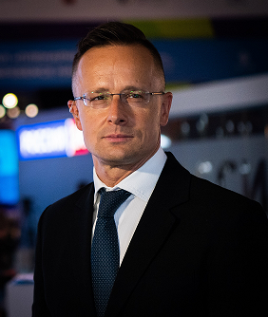

Born on 30th October, 1978 in Komárom.
Graduated from the Gergely Czuczor Benedictine High School of Győr in 1997, subsequently he conferred his degree in the faculty of Foreign Affairs at the University of Economic Sciences and Public Administration in 2002 in Budapest.
Has been Member of Parliament for Fidesz since 2002, having started his sixth term in 2022.
Communications Director of Fidesz between 2006 and 2010. Prime Minister’s Spokesperson between 2010 and 2012 and State Secretary for Foreign Affairs and External Economic Relations between 2012 and 2014.
Deputy Minister of Foreign Affairs and Trade between June and September, 2014 then Minister of Foreign Affairs and Trade of Hungary since 23th September, 2014.
Is a practising Roman Catholic, married with two sons. He was a registered futsal player, having played two games in 1st league and eighty-five in 2nd league between 2011 and 2016.

